Imperial Conversion
# Source: AI Source: Provided by: [Data Path: Persons Table -> ID Column: 1, Name_En Column: Motasem Essam] -> From: [ChatGPT] on [7/17/2026]
Imperial Conversion is the process of changing a measurement from one Imperial (or U.S. Customary) unit to another equivalent unit without changing the actual quantity being measured. Unlike the metric system, which is based on powers of 10, Imperial conversions use fixed conversion factors that vary between units.
Imperial conversions are commonly used in the United Kingdom (for some applications) and the United States (U.S. Customary Units), especially in construction, engineering, transportation, and everyday measurements.

Definition
# Source: AI Source: Provided by: [Data Path: Persons Table -> ID Column: 1, Name_En Column: Motasem Essam] -> From: [ChatGPT] on [7/17/2026]
Imperial Conversion is the process of converting a measurement from one Imperial unit to another equivalent Imperial unit while preserving the same physical quantity.

Purpose
# Source: AI Source: Provided by: [Data Path: Persons Table -> ID Column: 1, Name_En Column: Motasem Essam] -> From: [ChatGPT] on [7/17/2026]
Imperial conversion is used to:
- Express measurements in different Imperial units.
- Compare measurements consistently.
- Support engineering and construction.
- Interpret historical and technical documents.
- Communicate measurements in countries using Imperial units.

Characteristics
# Source: AI Source: Provided by: [Data Path: Persons Table -> ID Column: 1, Name_En Column: Motasem Essam] -> From: [ChatGPT] on [7/17/2026]
Imperial conversion:
- Uses fixed conversion factors.
- Is not decimal-based.
- Does not change the physical quantity.
- Requires memorizing or referencing conversion relationships.

Common Imperial Units

Length
# Source: AI Source: Provided by: [Data Path: Persons Table -> ID Column: 1, Name_En Column: Motasem Essam] -> From: [ChatGPT] on [7/17/2026]

Unit | Symbol
Inch | in
Foot | ft
Yard | yd
Mile | mi

Mass (Weight)
# Source: AI Source: Provided by: [Data Path: Persons Table -> ID Column: 1, Name_En Column: Motasem Essam] -> From: [ChatGPT] on [7/17/2026]
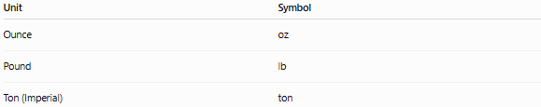
Unit | Symbol
Ounce | oz
Pound | lb
Ton (Imperial) | ton

Capacity (Liquid)
# Source: AI Source: Provided by: [Data Path: Persons Table -> ID Column: 1, Name_En Column: Motasem Essam] -> From: [ChatGPT] on [7/17/2026]
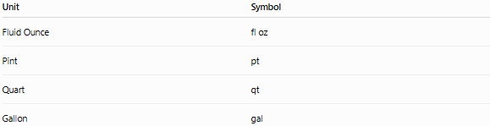
Unit | Symbol
Fluid Ounce | fl oz
Pint | pt
Quart | qt
Gallon | gal
Note: The Imperial gallon and the U.S. gallon are not the same size.

Length Conversions
# Source: AI Source: Provided by: [Data Path: Persons Table -> ID Column: 1, Name_En Column: Motasem Essam] -> From: [ChatGPT] on [7/17/2026]
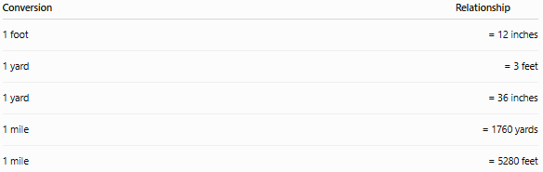
Conversion | Relationship
1 foot | = 12 inches
1 yard | = 3 feet
1 yard | = 36 inches
1 mile | = 1760 yards
1 mile | = 5280 feet
Examples
- 5 ft = 60 in
- 2 yd = 6 ft
- 4 mi = 7040 yd
- 10 ft = 3.33 yd (approximately)

Mass (Weight) Conversions
# Source: AI Source: Provided by: [Data Path: Persons Table -> ID Column: 1, Name_En Column: Motasem Essam] -> From: [ChatGPT] on [7/17/2026]
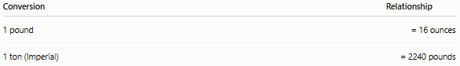
Conversion | Relationship
1 pound | = 16 ounces
1 ton (Imperial) | = 2240 pounds
Examples
- 5 lb = 80 oz
- 32 oz = 2 lb
- 4480 lb = 2 tons

Capacity Conversions (Imperial System)
# Source: AI Source: Provided by: [Data Path: Persons Table -> ID Column: 1, Name_En Column: Motasem Essam] -> From: [ChatGPT] on [7/17/2026]
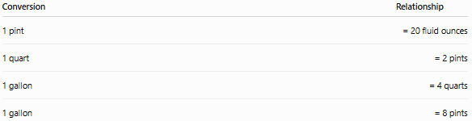
Conversion | Relationship
1 pint | = 20 fluid ounces
1 quart | = 2 pints
1 gallon | = 4 quarts
1 gallon | = 8 pints
Examples
- 3 qt = 6 pt
- 2 gal = 8 qt
- 40 fl oz = 2 pt

Capacity Conversions (U.S. Customary System)
# Source: AI Source: Provided by: [Data Path: Persons Table -> ID Column: 1, Name_En Column: Motasem Essam] -> From: [ChatGPT] on [7/17/2026]
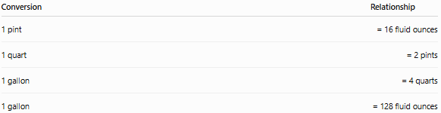
Conversion | Relationship
1 pint | = 16 fluid ounces
1 quart | = 2 pints
1 gallon | = 4 quarts
1 gallon | = 128 fluid ounces
Always verify whether measurements are Imperial or U.S. Customary, as some liquid units differ.

Area Conversions
# Source: AI Source: Provided by: [Data Path: Persons Table -> ID Column: 1, Name_En Column: Motasem Essam] -> From: [ChatGPT] on [7/17/2026]
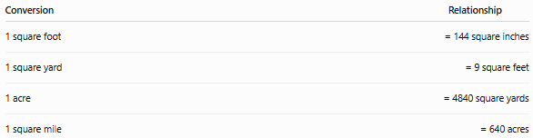
Conversion | Relationship
1 square foot | = 144 square inches
1 square yard | = 9 square feet
1 acre | = 4840 square yards
1 square mile | = 640 acres
Examples
- 3 ft² = 432 in²
- 2 yd² = 18 ft²
- 5 acres = 24,200 yd²

Volume Conversions
# Source: AI Source: Provided by: [Data Path: Persons Table -> ID Column: 1, Name_En Column: Motasem Essam] -> From: [ChatGPT] on [7/17/2026]
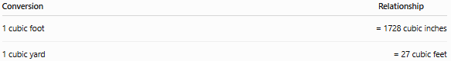
Conversion | Relationship
1 cubic foot | = 1728 cubic inches
1 cubic yard | = 27 cubic feet
Examples
- 2 ft³ = 3456 in³
- 3 yd³ = 81 ft³

Basic Conversion Rule
# Source: AI Source: Provided by: [Data Path: Persons Table -> ID Column: 1, Name_En Column: Motasem Essam] -> From: [ChatGPT] on [7/17/2026]
- Larger unit → Smaller unit: Multiply by the conversion factor.
- Smaller unit → Larger unit: Divide by the conversion factor.

Applications
# Source: AI Source: Provided by: [Data Path: Persons Table -> ID Column: 1, Name_En Column: Motasem Essam] -> From: [ChatGPT] on [7/17/2026]
Imperial conversion is used in:
- Construction
- Civil engineering
- Mechanical engineering
- Aviation
- Road transportation
- Manufacturing
- Carpentry
- Historical documents
- Everyday life in some countries

Imperial vs. Metric Conversion
# Source: AI Source: Provided by: [Data Path: Persons Table -> ID Column: 1, Name_En Column: Motasem Essam] -> From: [ChatGPT] on [7/17/2026]
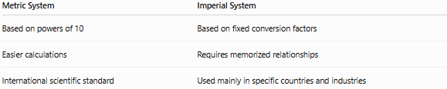
Metric System | Imperial System
Based on powers of 10 | Based on fixed conversion factors
Easier calculations | Requires memorized relationships
International scientific standard | Used mainly in specific countries and industries

Common Mistakes
# Source: AI Source: Provided by: [Data Path: Persons Table -> ID Column: 1, Name_En Column: Motasem Essam] -> From: [ChatGPT] on [7/17/2026]
- Confusing Imperial units with U.S. Customary units.
- Forgetting that 1 foot = 12 inches.
- Mixing metric and Imperial units without converting.
- Using the wrong gallon (Imperial vs. U.S.).
- Misapplying squared or cubed conversion factors for area and volume.

Key Points
# Source: AI Source: Provided by: [Data Path: Persons Table -> ID Column: 1, Name_En Column: Motasem Essam] -> From: [ChatGPT] on [7/17/2026]
- Imperial Conversion changes the unit, not the quantity.
- The Imperial system uses fixed conversion factors, not powers of 10.
- Common length units are inch, foot, yard, and mile.
- Common mass units are ounce, pound, and ton.
- Capacity units differ between the Imperial and U.S. Customary systems.
- Area and volume require square and cubic conversion factors.

Conclusion
# Source: AI Source: Provided by: [Data Path: Persons Table -> ID Column: 1, Name_En Column: Motasem Essam] -> From: [ChatGPT] on [7/17/2026]
Imperial Conversion is the process of expressing the same physical quantity in different Imperial units by applying fixed conversion factors. Unlike the metric system, Imperial measurements are not decimal-based, so conversions require specific relationships such as 12 inches per foot, 3 feet per yard, or 16 ounces per pound. Care must also be taken to distinguish between the Imperial and U.S. Customary systems, especially for liquid capacity units. Understanding Imperial conversions is important in construction, engineering, manufacturing, transportation, historical records, and regions where these measurement systems remain in use.

